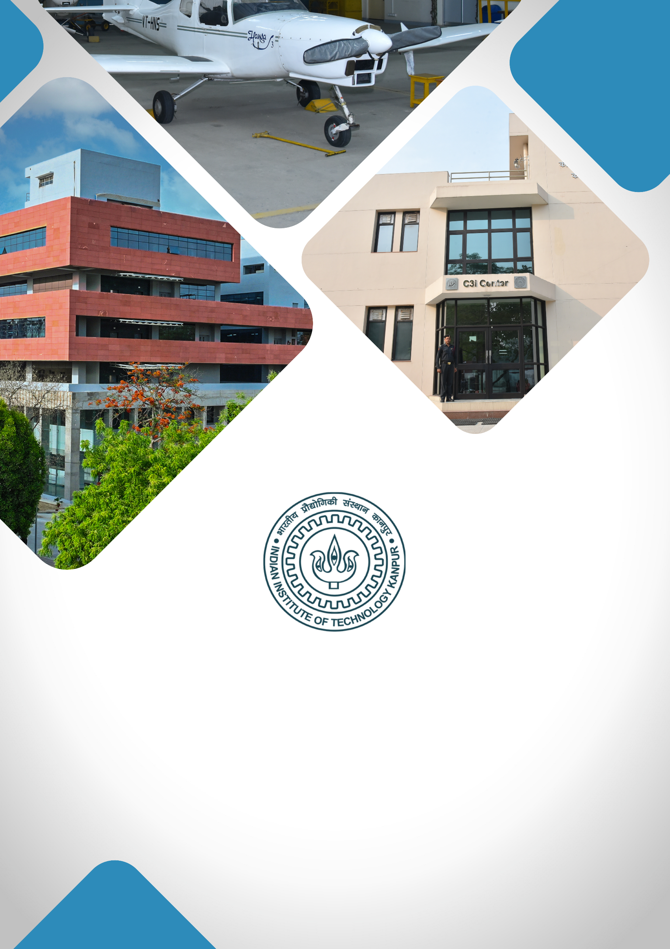

**BUILDING AN INNOVATIVE DRUG DISCOVERY ECOSYSTEM AT IIT KANPUR**

**TABLE OF CONTENTS**

1. **About IIT Kanpur**
2. **Institutional Vision**
3. **Project Title**
4. **Executive Summary**
5. **Background & Rationale / Motivation**
6. **Project Objectives**
7. **Expected Outcomes**
8. **Expected Impact**
9. **Milestones & Implementation Timeline**
10. **Financial Budget**
11. **Team Involved / Key Faculty Members**

**ABOUT IIT KANPUR**

**Indian Institute of Technology Kanpur**, established in 1959, is one of the premier institutions established by the Government of India. The aim of the Institute is to provide meaningful education, conduct original research of the highest standard, and provide leadership in technological innovation. The Institute has gained a legendary reputation in the country through its academic, social, and economic contributions. The combined record of its past and present faculty and students along with the alumni spread across the world is awe-inspiring.

From the start, the students have been provided education with a strong emphasis on the fundamentals of science and engineering and their application in the field of study. Subsequently, programs in humanities, management, and several interdisciplinary programs like design, environmental engineering and management, material sciences, nuclear engineering and technology, and photonic sciences and engineering programs were started. The education imparted to the students has stood by them even as they acquired new skills and knowledge during their professional careers.

IIT Kanpur continues to be a much sought-after destination for UG and PG studies. In the 65 years of its existence, over 43,000 students have graduated from the Institute. The alumni of IIT Kanpur have made their alma mater proud through their achievements and contributions in diverse fields like engineering, academia, business, entrepreneurship, and public service.

The Institute today has close to 600 full-time faculty members and all of them have earned their degrees from the top universities in the world. The Institute faculty members have often been bestowed with prestigious national honours as listed below:

|  |
| --- |
| Padma Shri |
| Infosys Prize (Infosys Science Foundation) |
| J C Bose Fellowship |
| Shanti Swarup Bhatnagar Prize for Science & Technology |
| Fellow, Indian National Science Academy (INSA), New Delhi |
| Fellow, Indian Academy of Sciences (IAS), Bangalore |
| Fellow, Indian National Academy of Engineering (INAE), New Delhi |
| Fellow, The National Academy of Sciences, India (NASI), Allahabad |
| Fellow, The World Academy of Sciences (TWAS), Italy |
| Humboldt Research Award |
| TWAS Prize |
| Wellcome Trust/India Alliance Early Career/Intermediate/Senior Fellowship |
| Tata Innovation Fellowship |

The Institute has a large pool of academic resources spanning 19 departments, 25 centers, and 3 Interdisciplinary programs in all engineering, science, design, humanities, and management disciplines. It has a student strength of more than 9000 across all programs.

IIT Kanpur has always laid strong emphasis on new academic initiatives that will allow the Institute to broaden its academic repertory and create an impact in academia and society. Some of these initiatives include the Department of Sustainable Energy Engineering and the Department of Cognitive Science which were established in the year 2020.

**INSTITUTIONAL VISION**

***"To create, disseminate, and translate knowledge in science, engineering, and allied disciplines that will best serve society."***

1. **Developing Technologies that Solve Real-World Problems:** Prioritising research and development that address critical societal challenges, translating innovations into solutions with high-TRL (Technology Readiness Level) technologies. The goal is to establish an Office of Translational Research within the Directorate for strategic guidance, funding support, industry connections, and information on government and industry needs.

**Major focus areas:**

* **Large-Scale AI Deployment**: Implementing AI solutions on a wide scale, focusing on impactful applications for government and industry sectors, including public grievance redressal and fraud detection.
* **MedTech:** Making healthcare accessible and affordable through cutting-edge research, device innovation, and medical training with the **Mehta Family Center**, **MedTech IITK**, and the **Gangwal School of Medical Sciences & Technology**.
* **Cybersecurity:** With **C3iHub**, focused on developing advanced solutions, supporting startups, and offering specialised training for critical cybersecurity needs.
* **Unmanned Aerial Vehicle (UAV) Technology**: Advancing UAV technology with a focus on defence, humanitarian, and disaster relief applications, and providing affordable testing facilities to promote industry growth.
* **Sustainability:** Positioning IIT Kanpur as a leader in sustainable development through technologies and initiatives led by the **Kotak School of Sustainability**, the **Chandrakanta Kesavan Centre** **for Energy Policy and Climate Solutions**, and the **Department of Sustainable Energy Engineering**.

1. **Elevating R&D Excellence:** Focus on recruiting top talent, creating state-of-the-art facilities, securing substantial research grants, and maintaining a balance between research quality and quantity.
2. **Enhancing Teaching Quality:** Achieving leadership inhigh-quality education by establishing a Centre for Teaching Excellence, developing courses in soft skills and technical writing, and introducing faculty career paths that focus on research, translational projects, or teaching.
3. **Enhancing Student Life and Campus Infrastructure:** Upgrading existing hostels and constructing new ones to accommodate growing student numbers. Developing state-of-the-art infrastructure within the campus.

**PROJECT TITLE**

**Building an innovative drug discovery ecosystem at IIT Kanpur**

**EXECUTIVE SUMMARY**

India is known as the pharmacy of the world and yet its contribution to the $1.5 trillion global pharmaceutical market remains below 5%. This is primarily because it is dominated by generic drug manufacturing. There exists a significant gap in the country’s capacity for innovative drug discovery which is driven by prohibitive costs, high failure rates in clinical trials and limited investment in Research & Development.

However, the primary ingredients for establishing a cutting-edge pipeline for innovative drug discovery are all represented in the diverse expertise that is currently present at IIT Kanpur. In fact, through strategic recruitment of leading scientists and establishing cutting-edge infrastructure, IIT Kanpur, has built a robust ecosystem which is poised to transform drug discovery in India. All that is needed is to bring together and synergize this diverse set of expertise under the umbrella of innovative drug discovery. By focusing on identification of novel therapeutic targets and using advanced structural biology, super-resolution imaging, genetics, genomics as well as cutting edge biophysical and biochemical techniques we aim to deliver innovative and affordable solutions for pressing healthcare challenges, including cancer, neurodegenerative diseases, metabolic disorders and rare diseases. Further, global MNCs would not be interested in developing drugs for tropical diseases which are endemic to India and other developing countries. This is further justification for developing an indigenous drug discovery program.

**BACKGROUND & RATIONALE**

India’s reliance on imported drugs and its limited innovation ecosystem in drug discovery highlight a critical need for homegrown solutions. By fostering a multidisciplinary environment that integrates genome analysis, structural biology, bioinformatics, and development of cell, tissue and animal-based disease models for preclinical research, IIT Kanpur aims to bridge the gap between fundamental research and translational drug development. This initiative will not only address unmet healthcare needs but also create an ecosystem where novel products can be transferred to pharmaceutical industries for large-scale development, significantly reducing costs and ensuring accessibility to life-saving drugs for the Indian population.

Our focus on high-impact areas—such as cancer, metabolic disorders, neurodegenerative diseases, and gene therapy—aligns with India’s growing healthcare demands, driven by an aging population and rising prevalence of non-communicable diseases. By leveraging IIT Kanpur’s unique capabilities, this initiative seeks to establish India as a global hub for innovative and affordable drug discovery.

A drug discovery pipeline involves the following three steps:

1. Understanding the disease mechanism

The BSBE department at IIT Kanpur has expertise in the domains of genetics, cell & molecular biology, structural & computational biology, as well as high-end microscopy, which can be leveraged to understand the disease mechanisms.

1. Developing therapeutic interventions

Expertise from the BSBE and Chemistry department will be brought together for designing and developing therapeutic interventions either in the form of small molecules or cell/gene-based therapy.

1. Evaluating the efficacy and accuracy of the intervention

BSBE department has the requisite expertise for generating cell/tissue and animal disease models and devising assays to evaluate the efficacy of the developed therapeutic interventions.

Although we have the required expertise and some of the basic infrastructure to establish a pipeline for innovative drug discovery, we are lacking the advanced equipment required to develop cutting-edge technology for the same.

**PROJECT OBJECTIVES**

1. **Understanding the disease mechanism & identification of the drug targets**

* To elucidate the basic mechanisms regulating biological processes using cell and animal models.
* To identify drug targets based on understanding disease mechanisms using large-scale genome and transcriptome analysis.

1. **Developing therapeutic interventions**

* To develop a pipeline for identifying candidate drug molecules using computational methods for structure-based studies and *in silico* docking experiments.
* To Identify candidate therapeutic molecules through high-throughput screening of synthesized/procured small molecule libraries and FDA-approved drug collections using cell/tissue and animal models.

1. **Evaluation of the efficacy and accuracy of the therapeutic interventions**

* To develop disease models and assays that can be used for preclinical studies to evaluate the efficacy and accuracy of the developed therapeutic interventions.

**INFRASTRUCTURE REQUIRED**

Several investigators in the BSBE department are actively engaged in studying the basic mechanisms and developing therapies in the context of cancer, metabolic disorders, neurodegenerative diseases, and rare disorders. However, to establish a cutting-edge pipeline for innovative drug discovery, we require the following infrastructure

1. **Advanced imaging platform for understanding disease mechanisms**

* Super-resolution STORM/PALM and SIM
* Advanced confocal microscope
* Lattice Light-sheet microscope

Advanced fluorescence microscopy platforms, equipped with technologies like confocal microscopy, super-resolution STORM/PALM, SIM and light-sheet microscopy, are revolutionizing drug discovery research. These tools enable researchers to visualize cellular and molecular processes with unprecedented resolution and speed, providing crucial insights into the mechanisms of disease and therapeutic interventions. By visualizing and understanding these processes better, researchers can find druggable nodes in diseases and design more targeted and effective medicines.

1. **Advanced biophysical characterization platform for drug discovery**

* High Field NMR Spectrometer

Structure determination of drug targets and interaction studies are critical for drug discovery. High Field NMR Spectrometry is a versatile method used to study biomolecules and perform biophysical analysis of drugs. It provides details about molecular binding, interactions, and conformations.

1. **Advanced biochemical characterization platform for drug discovery**

* Ultra-high-resolution Mass Spectrometer with Ultra HPLC
* Surface Plasmon Resonance spectrometer

Mass spectrometry (MS) offers structural information, enabling the identification and quantification of target-ligand interactions. Surface plasmon resonance (SPR) provides kinetic information on target-ligand interaction in real time

1. **Advanced screening platform for drug discovery**

* Multimode multiplate reader (Flex station-3)
* Extracellular flux analyser (Seahorse XF)
* High-throughput cellular screening system (FLIPR Penta)
* Multiplex plasma analyser
* 5-laser Flow Cytometer analyzer and sorter

Multimode multiplate reader, Extracellular flux analyser, High-throughput screening cellular system and Multiplex plasma analyser are used for screening of different types of libraries, including combinatorial chemistry, genomics, protein, and peptide libraries. This would accelerate drug discovery by screening large compound libraries at a rate that may exceed a few thousand compounds per day or per week.

Flow cytometry sorts cell populations with the desired phenotype from complex mixtures and helps in selecting transfected cells expressing specific targets for drug discovery.

1. **Advanced drug efficacy evaluation platform**

* In vivo multi-modal animal imaging facility
* Micro CT

In vivo imaging is a research field that uses advanced imaging techniques and molecular biology to image biochemical and physiological changes in a living body. It can be used to evaluate the effectiveness of potential drug candidates, and to understand the underlying mechanisms of diseases like cancer, diabetes, and cardiovascular disease. Integrating micro-CT with in-vivo imaging techniques will increase the reliability of data from preclinical studies of drug efficacy evaluation.

**EXPECTED OUTCOMES**

* **Discovery of Novel Therapeutic Targets:** Identification of new drug targets for diseases such as cancer, metabolic disorders, and neurodegenerative diseases.
* **Development of Target-specific Therapies:** Advancing candidate drugs with high specificity and efficacy through structural and functional studies.
* **Technology Transfer:** Providing innovative technologies and early-stage discoveries to pharmaceutical industries for large-scale development and commercialization.
* **Establishment of a National Research Hub:** Positioning IIT Kanpur as a leader in drug discovery, fostering collaborations, and driving national healthcare innovations.
* **Improved Accessibility:** Enabling affordable and effective therapies for Indian patients, reducing dependence on expensive imported drugs.

**PROPOSED IMPACT (SOCIAL / SCIENTIFIC)**

This initiative has the potential to transform India’s drug discovery landscape by addressing critical gaps in early-stage R&D and fostering an ecosystem of innovation. By identifying novel therapeutic targets and developing cost-effective, cutting-edge therapies, IIT Kanpur will address some of the most pressing healthcare challenges facing India today.

The translational focus of this initiative ensures that academic discoveries are seamlessly transitioned into scalable solutions for the pharmaceutical industry. This will not only reduce the cost of drug development but also make advanced therapies accessible to the Indian population. Furthermore, the program’s emphasis on emerging areas—such as aging biology, gut microbiota, and gene therapy—positions IIT Kanpur as a global leader in pharmaceutical research and innovation.

Through collaboration with industry partners, this initiative will drive economic growth, create employment opportunities, and establish India as a hub for affordable, innovative drug discovery. By addressing the unmet healthcare needs of the nation and contributing to the global pharmaceutical market, IIT Kanpur is set to redefine the future of drug development in India.

**MILESTONES & IMPLEMENTATION TIMELINE**

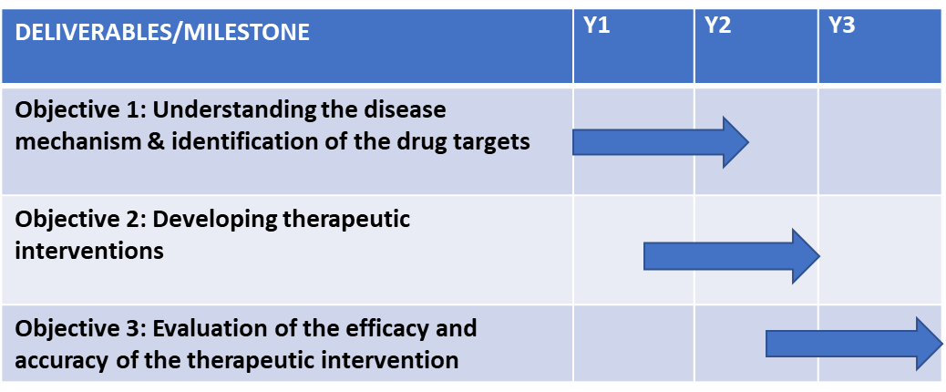

**BUDGET**

|  |  |
| --- | --- |
| Budget Head | Amount in  (INR) |
| Capital Expenditure (CAPEX) | |
| Equipment & Furniture | **130.7 Cr** |
| Operational Expenditure (OpEX) | |
| Contingency | **2 Cr per annum** |
| TOTAL | **136.7 Cr** |

|  |  |
| --- | --- |
| Split-Budget Heads | Amount in  (INR) |
| Advanced Imaging Centre 20 Cr | |
| Centre For Advanced Biophysical Characterization | **60 Cr** |
| Centre For Advanced Biochemical Characterization 15.5 Cr | |
| High-Throughput Drug Screening Facility | **19.2 Cr** |
| Preclinical Drug Efficacy Testing Centre | **16 Cr** |
| Contingency | **2 Cr per annum** |
| TOTAL | **136.7 Cr** |

